HANDWRITTEN DIGIT RECOGNITION USING CONVOLUTIONAL NEURAL NETWORK
Yohana Erukala, Student, Lpu(11804595)
GitHub: https://github.com/yohana143/INT248#deep_learning-and-tensorflow

Abstract:

We(Humans) can see and visually sense the world around us by using our eyes and brain. Computer vision works on enabling computers to see and process images in the same way that human vision does. Several algorithms had been developed in the area of computer vision to recognize images. The goal of our work is to create a model that will be able to identify and determine the handwritten digit from its image with better accuracy. We aim to complete this by using the concepts of Convolutional Neural Network and MNIST dataset. We will also show how different operations of CNN can be used to implement our model with CPU training as well as less training time. Finally our goal is to make our model to predict the digits.

Introduction:

Convolutional Neural Networks (CNN) becames one of the most advanced approaches and has been an ultimate factor in a variety of recent success and challenging machine learning applications such as challenge ImageNet object detection image segmentation and face recognition. Therefore, we choose CNN for our challenging tasks of digit recognition. We can use it for handwriting digits recognition which is one of high academic and business transactions. There are many applications of handwriting digit recognition in our real life purposes. like, we can use it in banks for reading checks, post offices for sorting letter, and many other related works.

MNIST database

The MNIST database (Modified National Institute of Standards and Technology database) is a handwritten digits dataset. We can use it for training various image processing systems. The database is also widely used for training and testing in the field of machine learning. It has 60,000 training and 10,000 testing examples.

Each image has fixed size. The images are of size 28*28 pixels. It is a database for people who want to try learning techniques and pattern recognition methods on real-world data while spending minimal efforts on preprocessing and formatting. We will use this database in our experiment.

Literature Review
S.no | Research Paper Name | year
1 | Handwritten Digit Recognition using Machine Learning Algorithms | 2018
2 | Image Classification with Deep Learning and Comparison between Different Convolutional Neural Network Structures using Tensorflow and Keras | 2018
3 | Understanding and Working with Keras | 2018
4 | DIGITNET: A Deep Handwritten Digit Detection and Recognition Method Using a New Historical Handwritten Digit Dataset | 2021
5 | An efficient and improved scheme for handwritten digit recognition based on convolutional neural network | 2019

Dataset :(mnist)

Proposed Architecture:

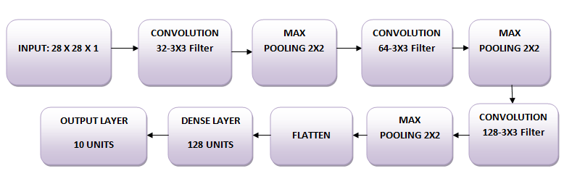

Simple Architecture

Max Pooling:

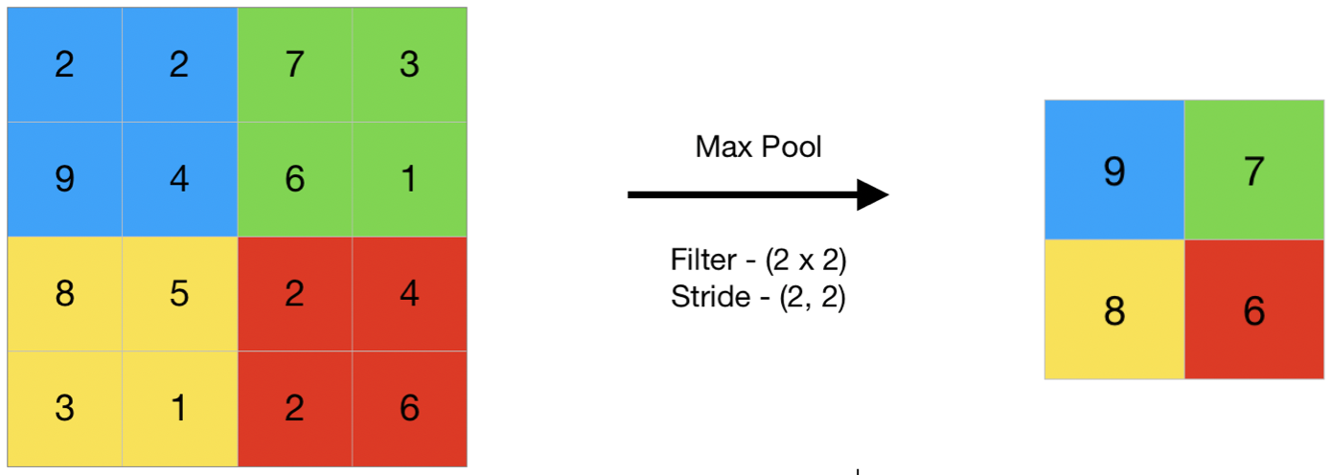

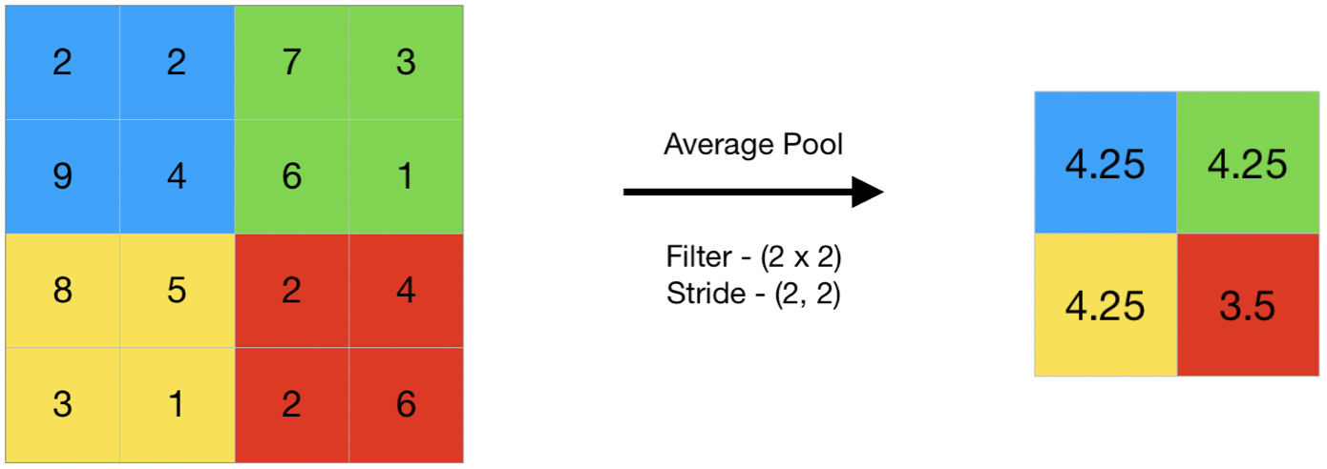

Result and Experiment Analysis:

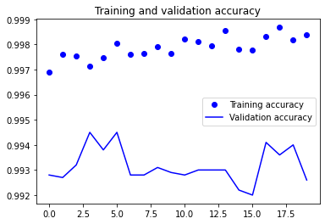

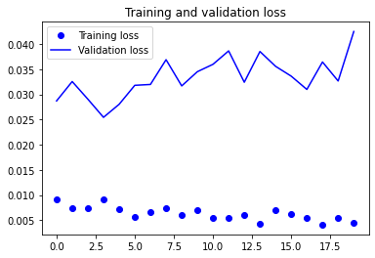

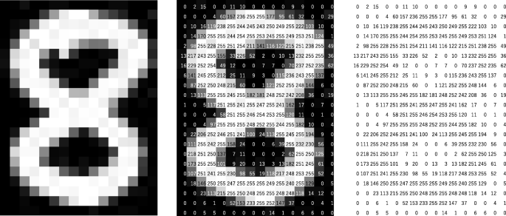

Screenshots:

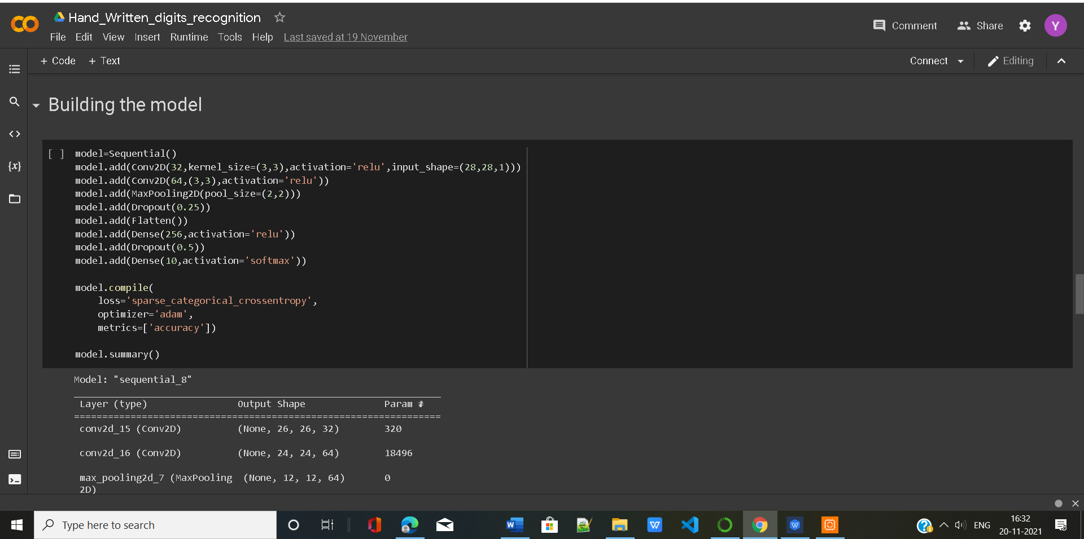

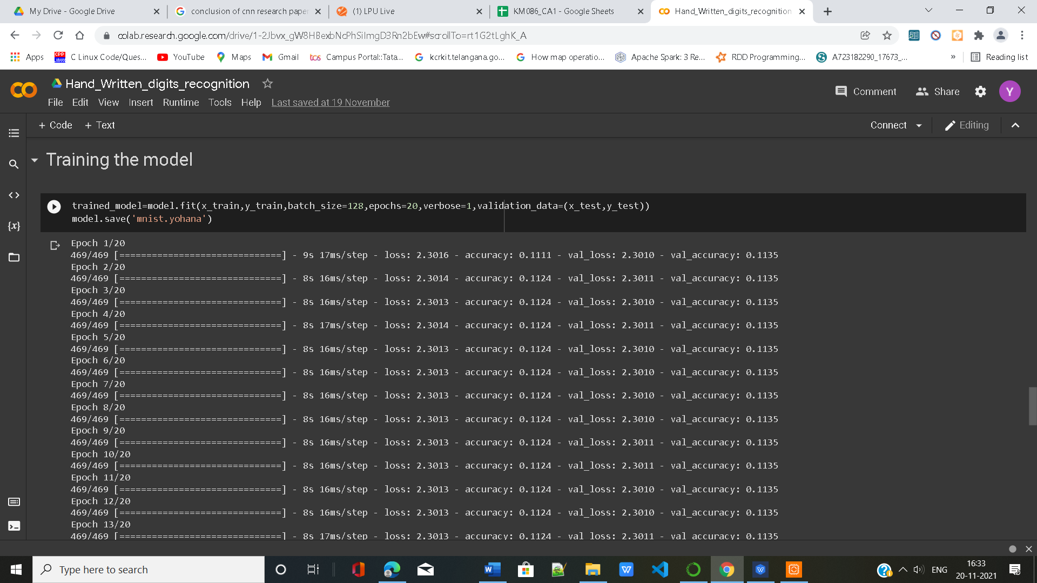

Conclusion and Future Scope:
Convolutional neural networks have achieved astonishing achievement in various domains including business,medical research etc.Though Deep learning has become a dominant approach in a variety of complex tasks like image classification and object detection but it was not able to solve that CNN can do using it.In future CNN has lot of scope that even it is applied in driver less cars for object detection and even more.

References:
Internet

